**IT314 – Software Engineering**



**Group 25**

**Diagnosis Expert System**

Table of content

Introduction: Non-Functional Testing 1

1. Performance Testing: 2

2.Compatibility testing: 3

3. Reliability and Availability Testing: 7

# Introduction: Non-Functional Testing

This document outlines the non-functional testing strategy to ensure the system's performance, security, and overall reliability.

## 1. Performance Testing:

Objective: To assess the system's responsiveness, scalability, and overall performance under various conditions.

Tools used: Blaze-meter

This test is conducted on 2 CPU and 1 fixed location US East Virginia Google cloud. Maximum users considered is 50 at a time for 10 minutes at 1 minute ramp up time. Errors noticed are 0.

Moreover for Pages which needs authentication it shows error 403 Forbidden and its error percentage is 100 as it is not able to access that page. This fulfill the acceptance criteria.

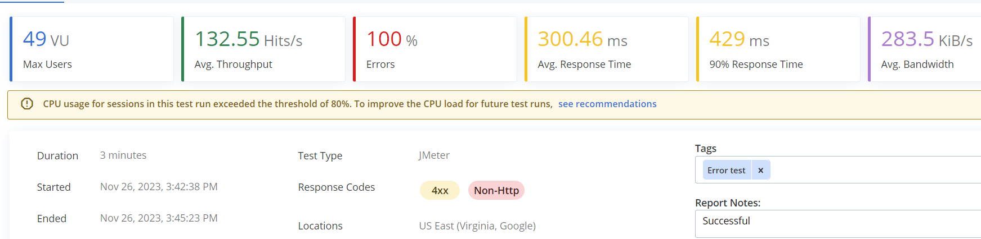

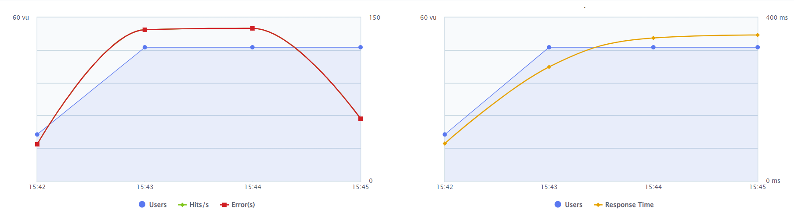

We claim up to 1 lakh hits in 1 hour.



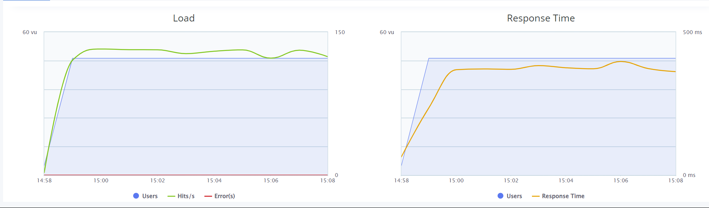

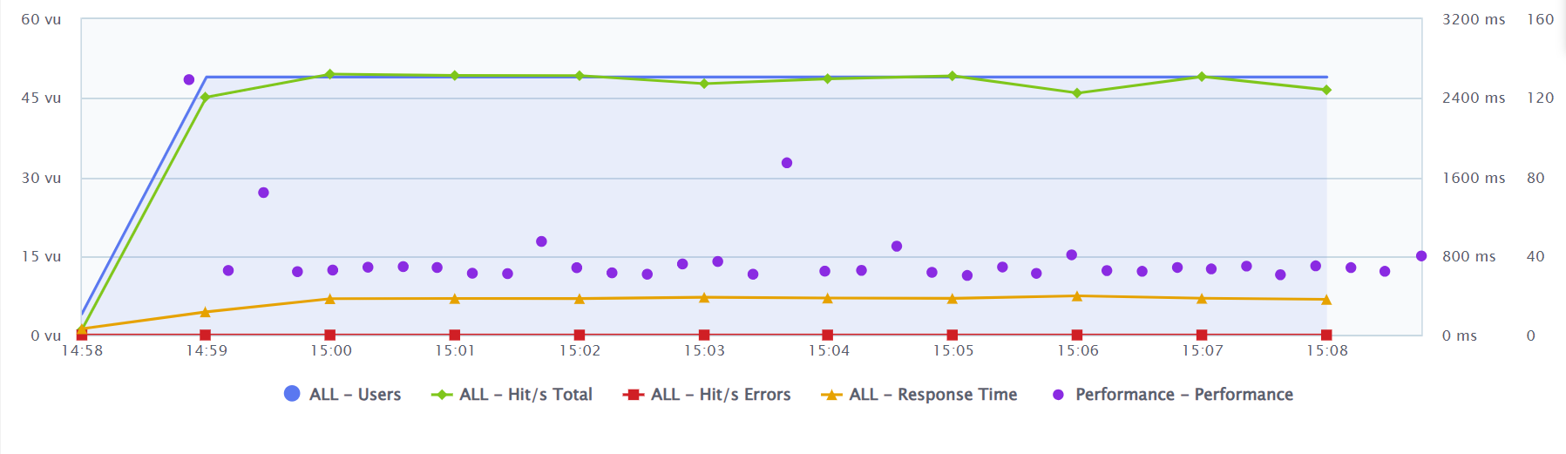





## 2.Compatibility testing:

Objective: To ensure the website functions consistently across different browsers, devices, and operating systems.

Tools: Sauce Labs, providing cloud based cross browsing

Windows 11 - Brave: version 118 , Resolution: 1496x 705

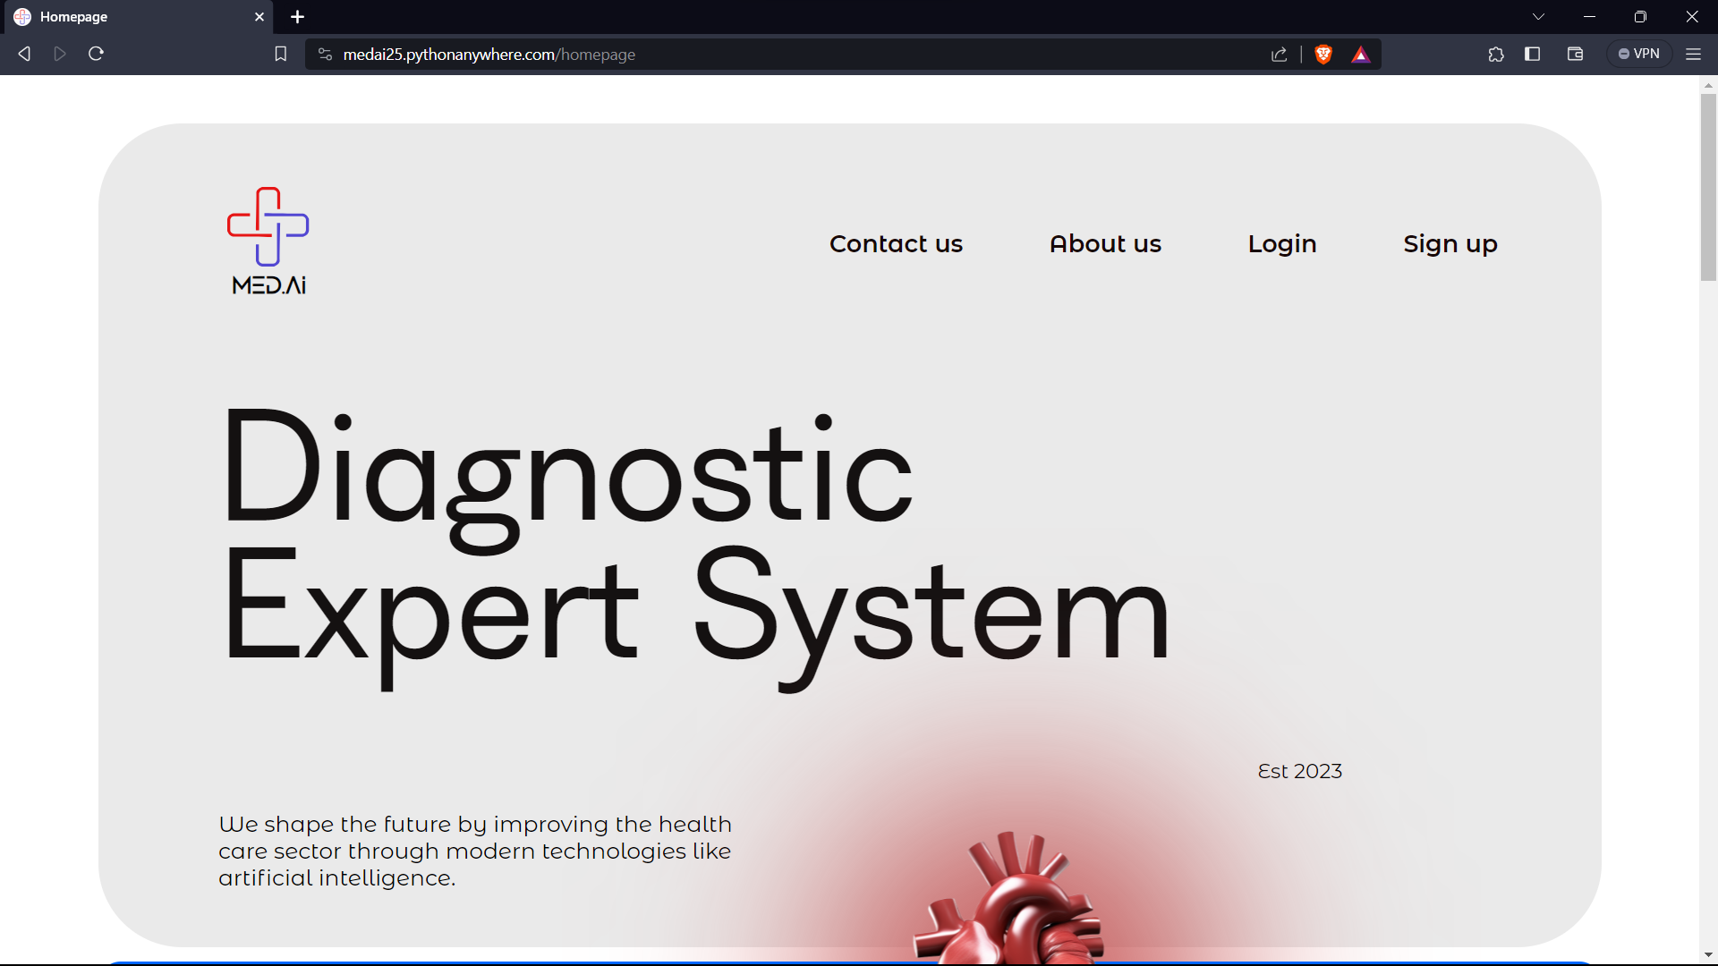

Windows 11 – Microsoft Edge: version 118 , Resolution: 1440x900

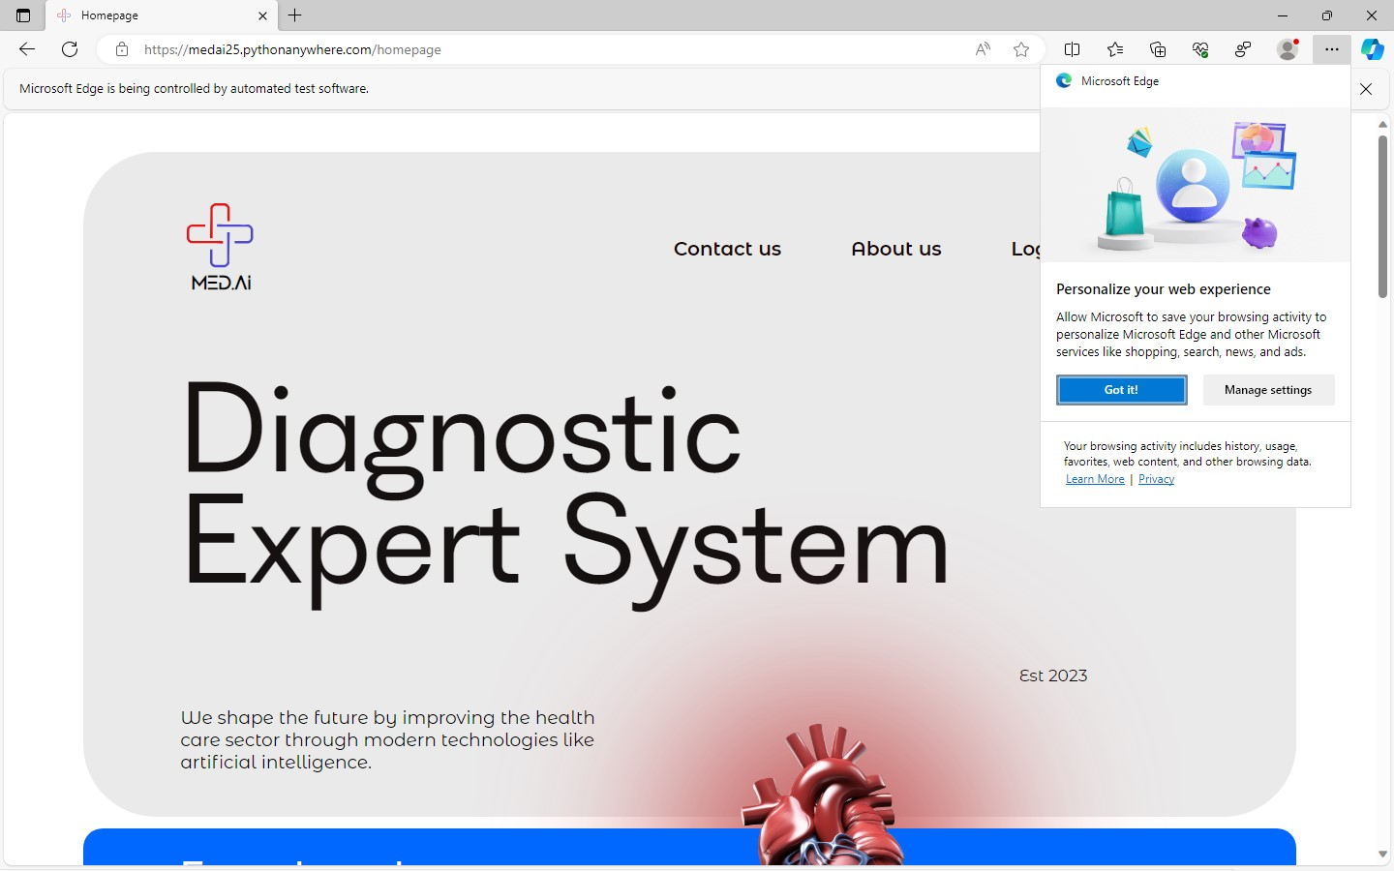

Windows 11 - Opera – version 105. Resolution : 1536 x 796

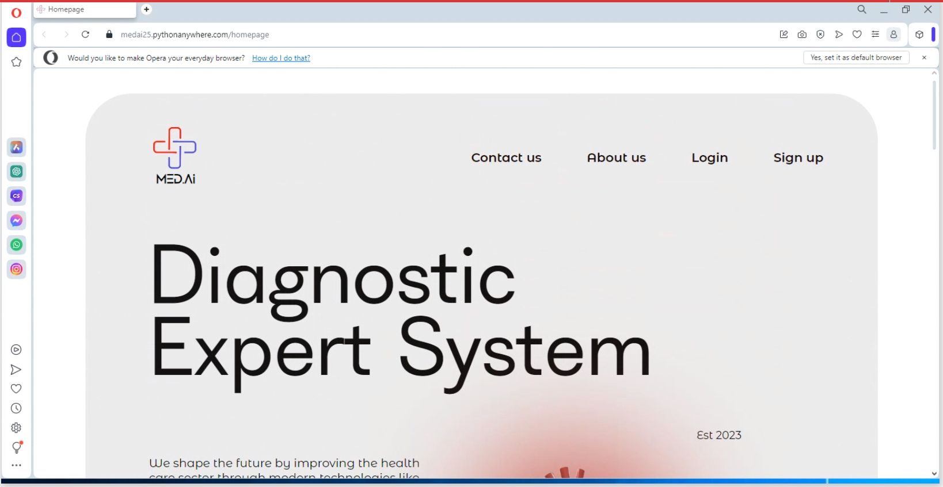

MacOS- Safari 15 Monterey Resolution 1440x900

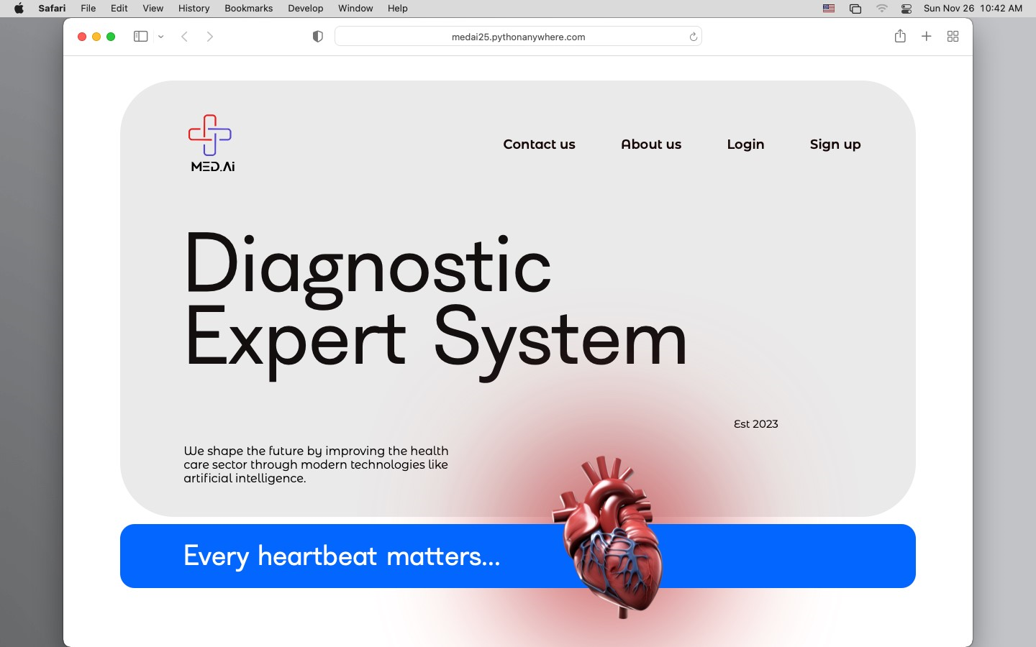

Windows 11- Chrome Version 119 Resolution 1496x900

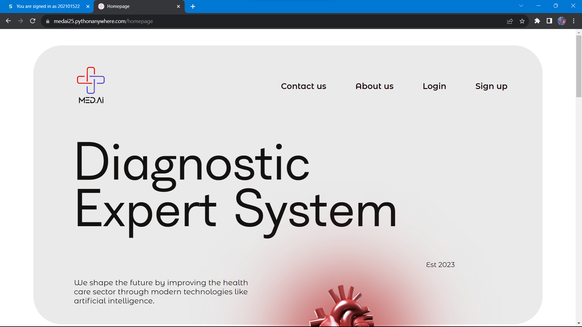

MacOS- Safari 17 Sonoma Resolution 1440x900



It is observed that the website is compatible to almost all the version of web browsers and across different system like Mac, windows and linux.

## 3. Reliability and Availability Testing:

Objective: To ensure the system's reliability and availability under different conditions.

Tool used: Uptime Robot

The monitor tracking is implemented and the website is live 24 hrs.

Any issue noticed would be notified to the user through mail from uptime robots.

HTTP Request and its response time

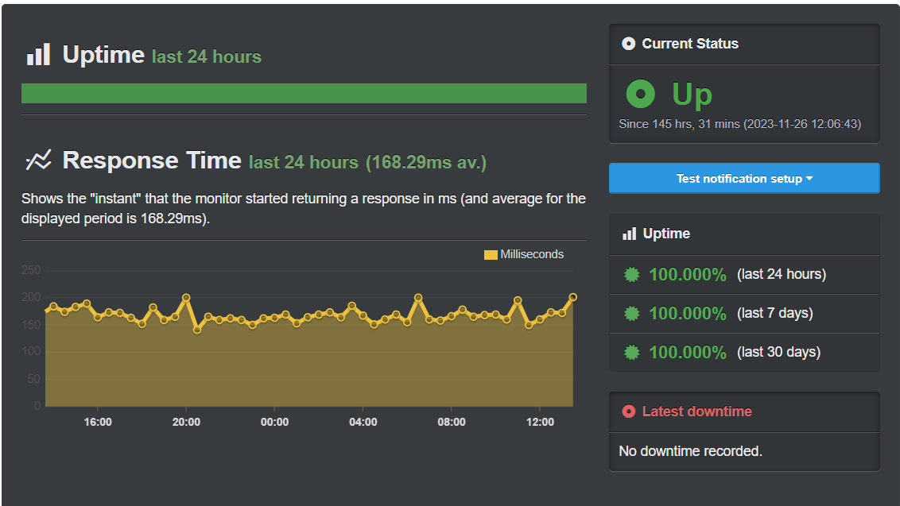

Ping and its response time

